BREAKFAST CHATTER
Weekly Bulletin of Rotary Club of Kathmandu Mid-Town
District 3290 Volume No. 15/17 for #759 November 12, 2004
www.rotarymidtown.org.np
NOVEMBER IS ROTARY FOUNDATION MONTH

SUNSHINE ANNOUNCEMENT FOR THE WEEK OF 12 NOVEMBER 2004;
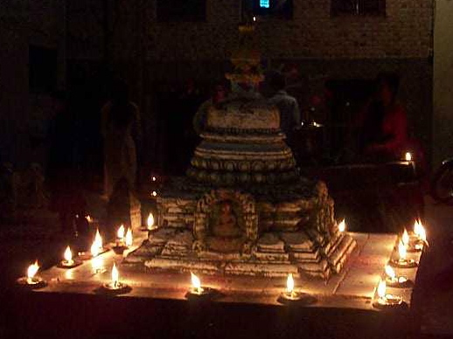
Success and best wishes to Usha, spouse of Niranjan, and to Gopal, both on the 20th!

***************
And happy Deepawali on Friday. Enjoy the light!
*******************

MEETING ACTIVITIES:
DATE | ACTIVITY | SUBJECT
12 NOV | Roshan Shrestha | Biosand filter for water quality
19 NOV | to be announced | to be announced
28 NOV | Dinner Meeting | Combo Charter Night & Taiwan Guests
3 DEC | to be announced | to be announced
10 DEC | Rabi Karmacharya | Software Outsourcing Prospects for Nepal
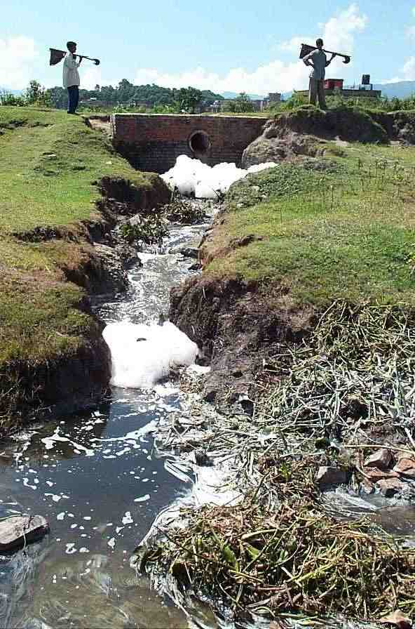
****************
NEWS: Deep thanks to the Rotarians who helped the Nepali Muslims whose businesses were targeted in the recent riot. Mr. Taj Mohammad Miya gracefully accepted a check from Mid-Town on behalf of the Nepal Muslim Ettehad Organization which will distribute the funds *** Upcoming on the 28th --- note that the next phase of the eye/medical camp will take place next to Tilganga Eye Hospital, with assistance from Shanti Sewa Griha and participation from our visiting Taiwan group --- followed by the evening event. More details next week ***
****************
THIS WEEK’S PRESENTATION BY ROSHAN SHRESTHA
Ground and surface water contamination is widespread. ENPHO is a leader in water analysis and in remediation technology. Roshan will address their work on this widespread problem using the ‘Biosand Filter’. Chemical contamination shown here is in Patan - flowing into the Manohara river.
**************** YIR…David

